Dalton Murray

Human Computer Interaction

INT 3603 - 3452-202320_INT3603_OL

Professor Darren Hood

February 5, 2022

**Lab 2**

**(All images can be found and labeled here:** [**https://drive.google.com/drive/folders/1ponB18SXgtNKdoHuLg_dVQ6mM0it3cy8?usp=sharing**](https://drive.google.com/drive/folders/1ponB18SXgtNKdoHuLg_dVQ6mM0it3cy8?usp=sharing) **)**

I initially wanted to do this lab on Google, however, I realized that the website may be too simplistic to be able to properly do this lab on it. So, I decided to do this lab on multiple different websites and analyze them all.

**Google**

I wanted to test Google because it is a website, I feel that a lot of people visit, including colorblind people, however, after reviewing it, it is very simple and isn’t really impacted by colorblindness too much.

In order to properly test Google, simply putting in the website google.com will not work properly because it will not actually give any search results and would just be the landing page of Google with their logo and a search box, which seemed to be perfectly fine in testing. I decided to put in the search term “color blindness test” which looks like Image 1. With the regular Google site it is extremely easy to navigate, and everything is right where it feels like it should be at. When switching to different colorblindness’s the Google website still looks very similar and easy to use.

The only problem I am able to find with Google’s website when looking at different colorblindness’s is in Greyscale/Achromatopsia. The links and everything look a little too faded/light, however, the website looks like it can still be easily used. With the greyscale colorblindness it is completely usable but could definitely be improved upon.

**Images**

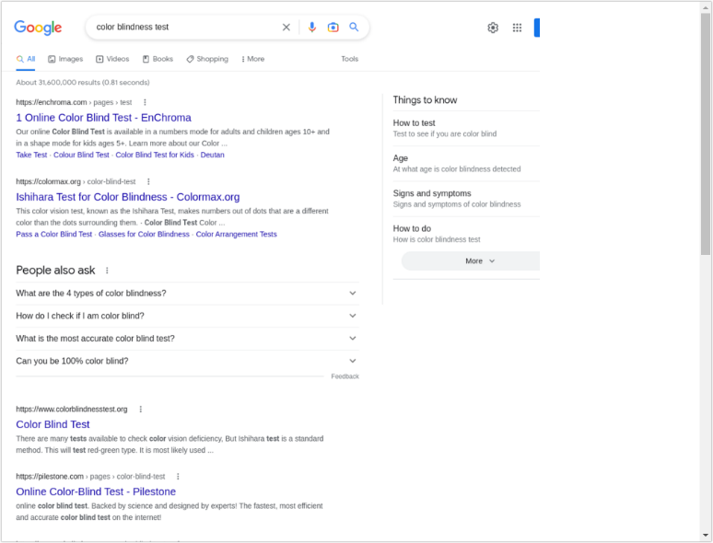

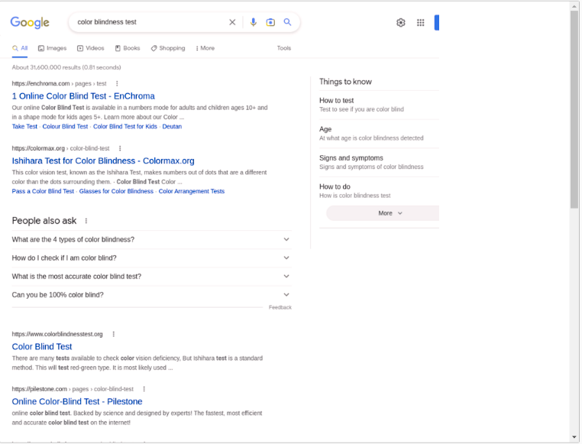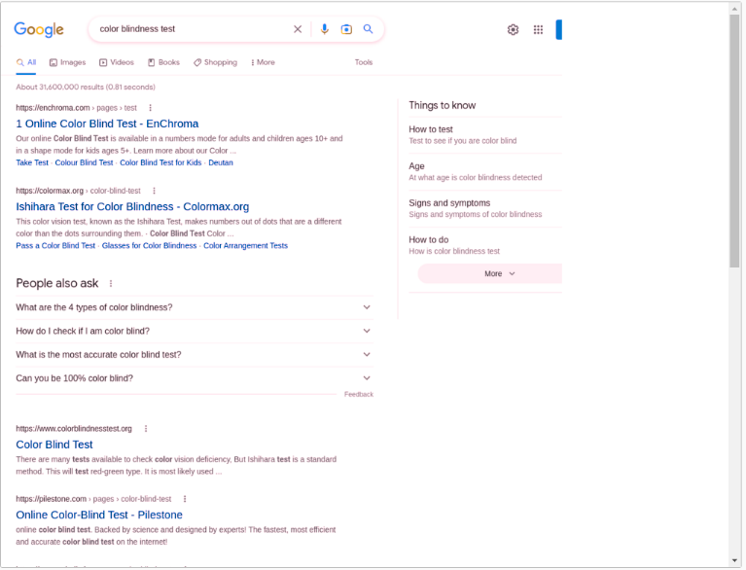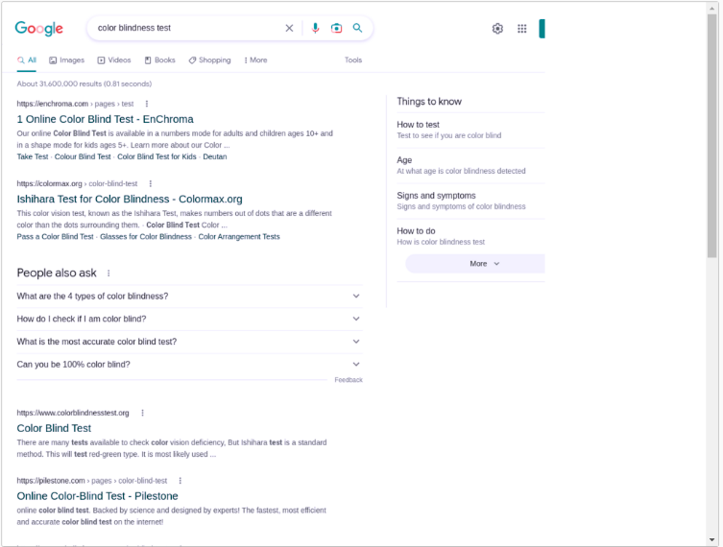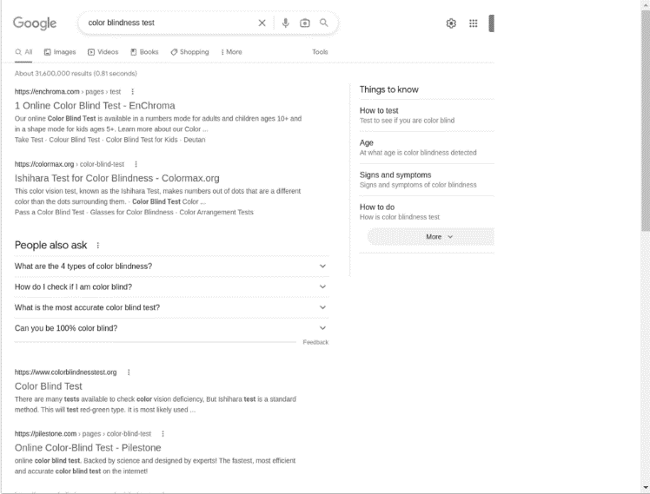

**Microcenter**

I initially wanted to evaluate a product page on Amazon, however, its bot protection stopped me from doing so, which is why I chose to evaluate Microcenter.

When evaluating Microcenter I picked on a random product page and evaluated the different colorblindness’s from this page rather than doing it on the landing page, this is so I am able to get a wider range of information and stuff on the page to evaluate from. However, I did test the initial landing page and it seems to be alright.

The link to the product page which I am testing this on is here: <https://www.microcenter.com/product/662679/asus-rog-zephyrus-g15-ga503qs-bs96q-156-gaming-laptop-computer-gray>

Protanopia – When reviewing this page with protanopia colorblindness, I am able to find everything easily and figure out all critical information such as store, price, adding to cart, and all details about the laptop very easily. The website is also easy to navigate and has good contrast between everything.

Deuteranopia – When reviewing this page with deuteranopia colorblindness everything also looks good and is clearly visible. However, the page it feels like needs to use less white as it’s a little too bright and restricting some vision on certain things, making boundaries and divisions a little rough to look at.

Tritanopia – When reviewing this page with tritanopia colorblindness, I find it odd, however, I actually like it more than the regular website. Tritanopia makes the divisions and text stand out a little more and have a slight blue tint to everything, everything looks perfectly usable.

Greyscale/Achromatopsia – When reviewing this page with greyscale/achromatopsia everything is usable and not too bright or too dark or even very faded like other websites in review had problems with. There are minimal issues with text on images and being able to properly read it.

**Images**

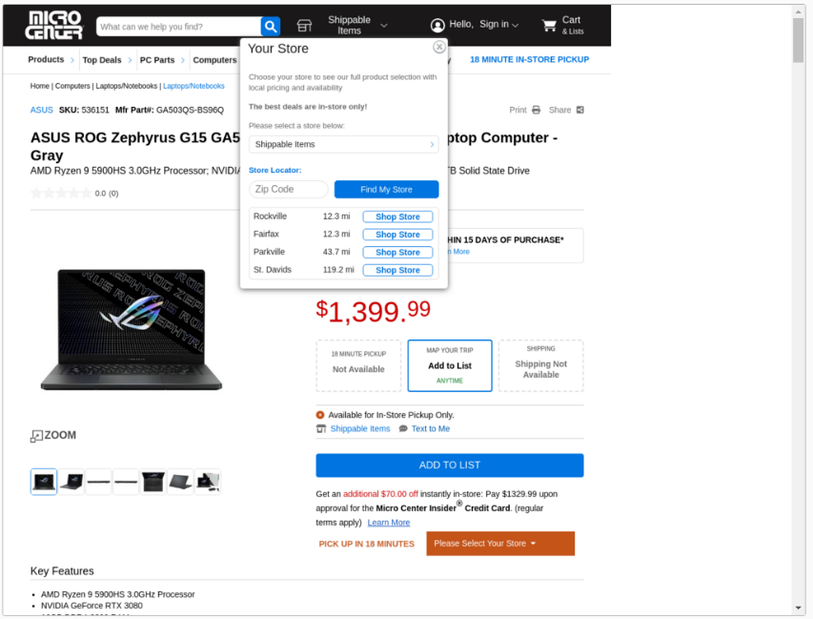

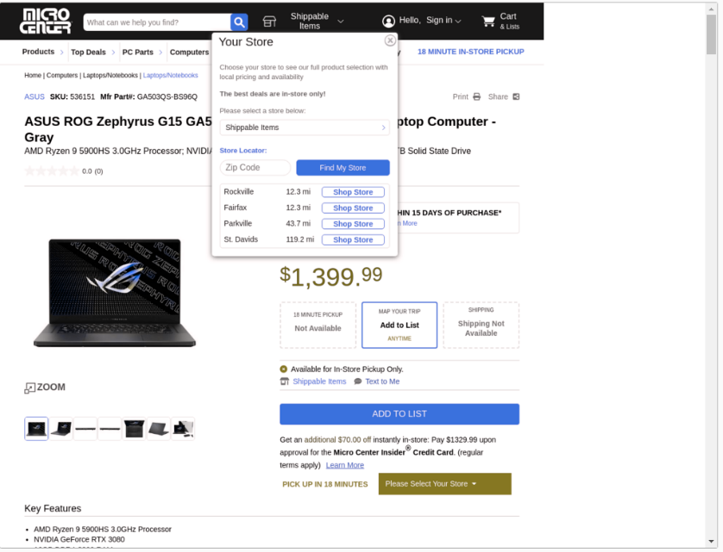

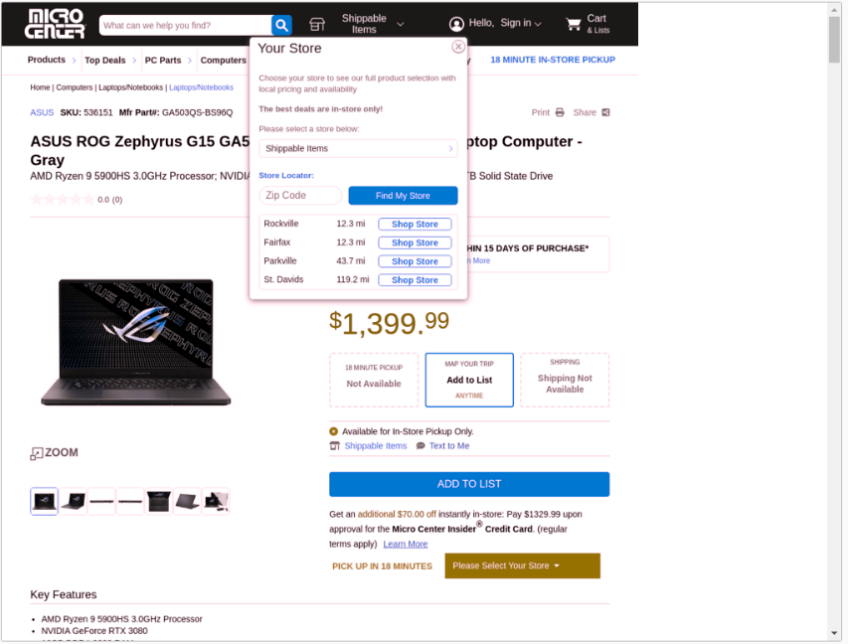

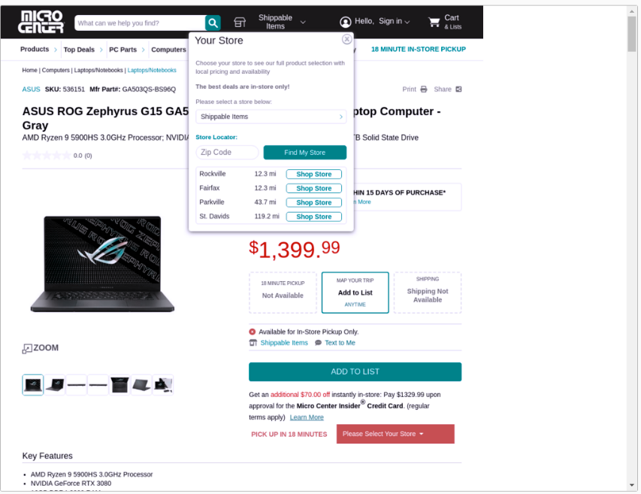

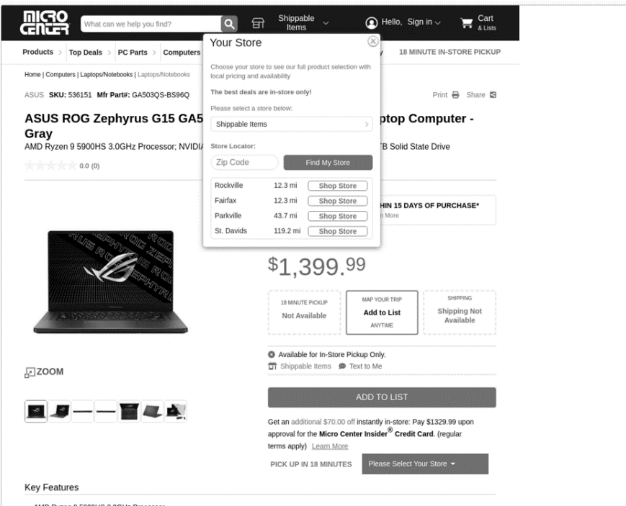

**Wikipedia**

I wanted to also do another website which is commonly used and I figured out that Wikipedia would be a great website to do this test on. I am testing specifically with the Color blindness page, linked here: <https://en.wikipedia.org/wiki/Color_blindness> . A critical element of this page which I am looking at is the actual picture which shows a lot of dots and colors which has the number 74 in it.

Protanopia – The Wikipedia page itself looks good with this type of colorblindness, however, we are able to see that the image with the number is no longer there/has the number clearly visible or is at least very difficult to see.

Deuteranopia – With the Wikipedia page with deuteranopia, the image itself has the number a little visible, but is hard to see. However, the page itself is looking a little rough, and I believe that making it use less full white will make it look better to help prevent difficulties seeing.

Tritanopia – With tritanopia the number is very visible, and the webpage looks decent. Everything is visible with tritanopia, and the website has less of a harsh white than without colorblindness’s.

Greyscale/Achromatopsia – With greyscale/achromatopsia, the number is barely visible for me, however, is still fairly visible. The website itself, however, looks quite a bit worse, and a lot of text is faded, specifically where they use the light blue links. A lot of different things are much more difficult to see.

**Images**

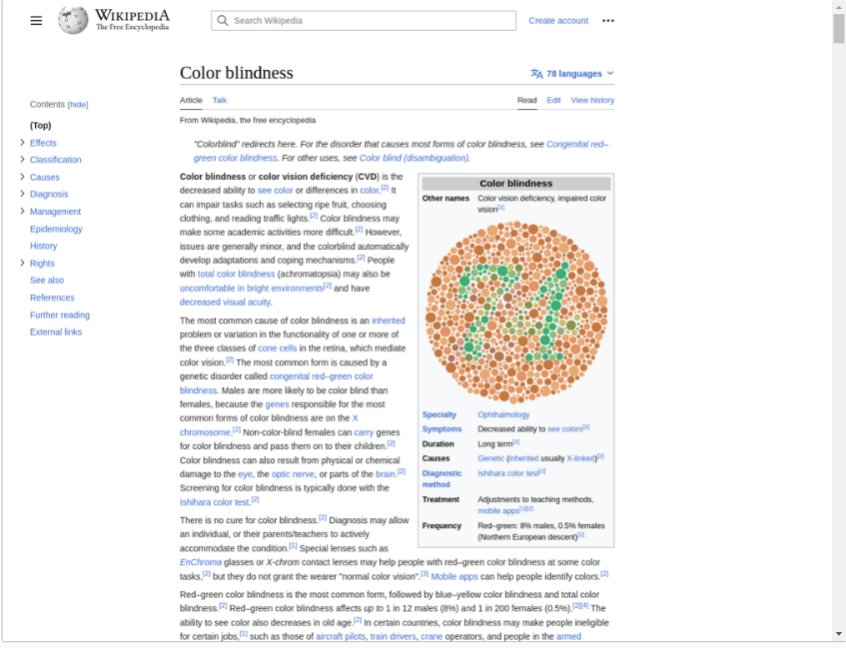

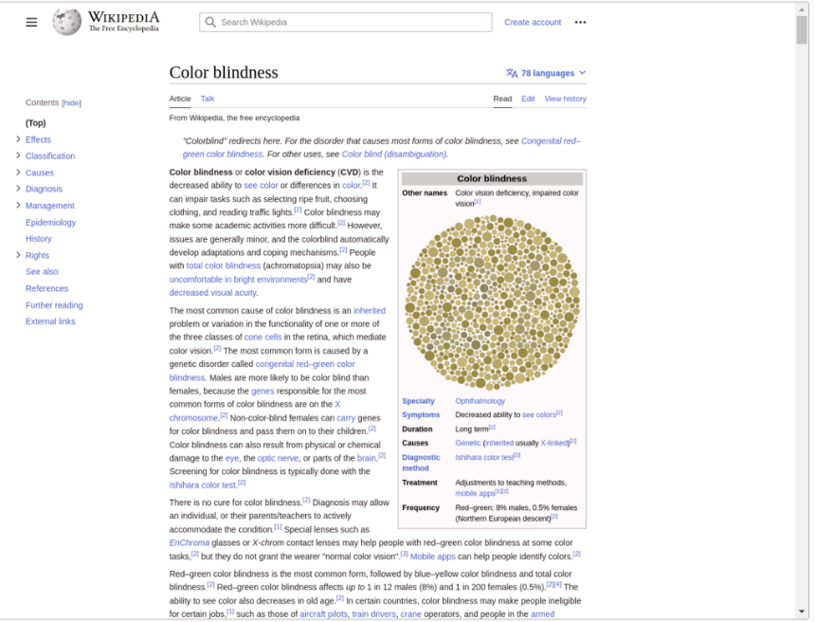  
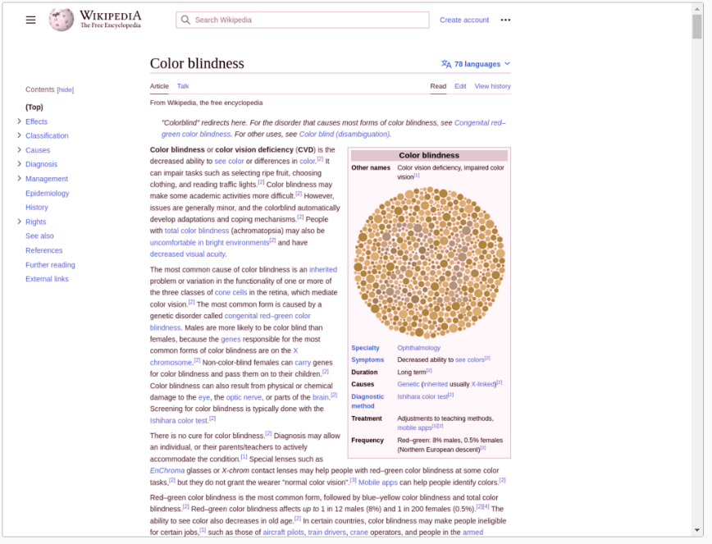

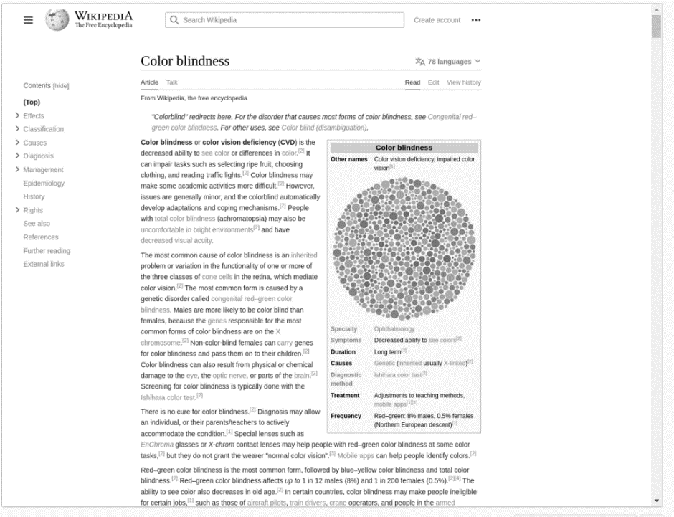

**Overview**

A lot of websites seem to handle colorblindness decently well. However, when there are issues with websites there usually is not a way to fix them. I think websites should be including more built in tools to help with colorblindness, such as a dark mode, and high contrast mode.

It seems that when coding with HTML, CSS, and general website frameworks and languages there isn’t really any sort of built-in way of handling colorblindness, which I wish there would be more of. Although, generally, most websites seem to work OK with different colorblindness’s. The Wikipedia page, which has the colorblindness test image really goes to show what someone may be missing on a website.

This lab really has me also thinking about other disabilities and how people are able to interact with websites, as demonstrated to me by this lab it is clear a lot of websites (I tested a lot more than the ones shown on this document) do not understand principles of colorblindness or basic accessibility. Website designers and programmers really need to make easy to use customizability options for people with disabilities such as a dark theme or high contrast theme or themes built for specific colorblindness’s, as well as make sure that other types of disabilities are able to use the website properly. I feel that to make sure website designers and programmers are able to do this they need to test it themselves, for example, the website we used for the lab showed how people with different colorblindness’s actually see the website, and that website programmers and designers can do different things to test different disabilities such as full blindness or people who have trouble navigating websites by use of their hands.

I have neither given nor received unauthorized aid in completing this work, nor have I presented someone else's work as my own.

*Dalton Murray*